ASSIGNMENT

AIM: To create an Apollo Hospital Management website using html, css and javascript code
CODE: DOCTYPE html>
<html lang="en">
<head>
<meta charset="UTF-8" />
<meta name="viewport" content="width=device-width, initial-scale=1.0" />
<title>

MediCare Hospitals - Best Hospital in India - Hospital Appointment Booking</title>
<link rel="stylesheet" href="style.css" />
<link href="https://fonts.googleapis.com/css2?family=Inter:wght@300;400;500;600;7 00&family=Poppins:wght@400;500;600;700&display=swap" rel="stylesheet"
/>
</head><!
<body>

<!-- Navigation Bar -->
<nav class="navbar">
<div class="nav-container">
<a href="#" class="nav-logo">
<span class="logo-icon">+</span> MediCare Plus
</a>
<input type="checkbox" id="nav-toggle" />
<label for="nav-toggle" class="nav-toggle-label">

<span></span>
<span></span>
<span></span>
</label>
<ul class="nav-links">
<li><a href="#home">Home</a></li>
<li><a href="#about">About</a></li>
<li><a href="#doctors">Doctors</a></li>
<li><a href="#hospitals">Hospitals</a></li>
<li><a href="#services">Services</a></li>
<li><a href="#appointment">Appointment</a></li>
<li><a href="#contact">Contact</a></li>
</ul>
</div>
</nav>

<!-- Hero Section -->
<section id="home" class="hero">
<div class="hero-overlay"></div>
<div class="hero-content">
<h1>Book Your Hospital Appointment Easily</h1>
<p>Trusted Healthcare Services With Experienced Doctors</p>
<a href="#appointment" class="btn btn-primary">Book Appointment</a>
</div>
</section>

<!-- About Section -->
<section id="about" class="about">
<div class="container">
<h2 class="section-title">About Our Hospital</h2>
<div class="section-divider"></div>
<div class="about-content">
<div class="about-text">
<p>Apollo Hospitals is a leading healthcare platform dedicated to providing world-class medical services to patients across the country. With a network of over 20 top-tier hospitals and 500+ experienced doctors, we ensure that quality healthcare is always within your reach.</p>
<p>Our hospitals are equipped with state-of-the-art medical facilities, advanced diagnostic laboratories, and 24/7 emergency support. From routine checkups to complex surgeries, our team of highly skilled specialists delivers compassionate care tailored to every patient's needs.</p>
<p>We believe that healthcare should be accessible, affordable, and transparent. Our online appointment booking system allows you to choose your doctor, hospital, and preferred time slot — all from the comfort of your home. Experience healthcare reimagined with MediCare Plus.</p>
</div>
<div class="about-stats">
<div class="stat-card">
<span class="stat-number">500+</span>
<span class="stat-label">Expert Doctors</span>
</div>
<div class="stat-card">
<span class="stat-number">20+</span>
<span class="stat-label">Hospitals</span>
</div>

<div class="stat-card">
<span class="stat-number">50K+</span>
<span class="stat-label">Happy Patients</span>
</div>
<div class="stat-card">
<span class="stat-number">24/7</span>
<span class="stat-label">Emergency Support</span>
</div>
</div>
</div>
</div>
</section>

<!-- Services Section -->
<section id="services" class="services">
<div class="container">

<h2 class="section-title">Our Services</h2>
<div class="section-divider"></div>

<div class="services-grid">

<!-- Emergency Care -->
<div class="service-card">
<div class="service-icon">
<img src="https://images.pexels.com/photos/1170979/pexels-photo-1170979.jpeg?auto=compress&cs=tinysrgb&w=200" alt="Emergency Care">

</div>
<h3>Emergency Care</h3>
<p>
Round-the-clock emergency medical services with fully equipped trauma centers and rapid response teams for critical situations.
</p>
</div>

<!-- Heart Checkup -->
<div class="service-card">
<div class="service-icon">
<img src="https://images.pexels.com/photos/4386466/pexels-photo-4386466.jpeg?auto=compress&cs=tinysrgb&w=200" alt="Heart Checkup">
</div>
<h3>Heart Checkup</h3>
<p>
Comprehensive cardiac evaluations including ECG, echocardiography, and stress tests by experienced cardiologists.
</p>
</div>

<!-- Dental Care -->
<div class="service-card">
<div class="service-icon">
<img src="https://images.pexels.com/photos/3845810/pexels-photo-3845810.jpeg?auto=compress&cs=tinysrgb&w=200" alt="Dental Care">
</div>

<h3>Dental Care</h3>
<p>
Complete dental solutions from routine cleanings to advanced cosmetic dentistry and orthodontic treatments.
</p>
</div>

<!-- Neurology -->
<div class="service-card">
<div class="service-icon">
<img src="https://images.pexels.com/photos/7088524/pexels-photo-7088524.jpeg?auto=compress&cs=tinysrgb&w=200" alt="Neurology">
</div>
<h3>Neurology</h3>
<p>
Expert neurological diagnosis and treatment for brain, spine, and nervous system disorders with advanced imaging.
</p>
</div>

<!-- Laboratory -->
<div class="service-card">
<div class="service-icon">
<img src="https://images.pexels.com/photos/3825527/pexels-photo-3825527.jpeg?auto=compress&cs=tinysrgb&w=200" alt="Laboratory">
</div>
<h3>Laboratory</h3>

<p>
Full-service diagnostic laboratory with accurate test results for blood work, pathology, and advanced diagnostics.
</p>
</div>

<!-- Pharmacy -->
<div class="service-card">
<div class="service-icon">
<img src="https://images.pexels.com/photos/7615574/pexels-photo-7615574.jpeg?auto=compress&cs=tinysrgb&w=200" alt="Pharmacy">
</div>
<h3>Pharmacy</h3>
<p>
In-house pharmacy stocked with genuine medications available 24/7 for inpatients and outpatients convenience.
</p>
</div>

<!-- Ambulance Service -->
<div class="service-card">
<div class="service-icon">
<img src="https://images.pexels.com/photos/8949833/pexels-photo-8949833.jpeg?auto=compress&cs=tinysrgb&w=200" alt="Ambulance Service">
</div>
<h3>Ambulance Service</h3>
<p>

Quick ambulance dispatch with GPS-tracked vehicles and trained paramedics for safe patient transport.
</p>
</div>

<!-- Pediatric Care -->
<div class="service-card">
<div class="service-icon">
<img src="https://images.pexels.com/photos/5998476/pexels-photo-5998476.jpeg?auto=compress&cs=tinysrgb&w=200" alt="Pediatric Care">
</div>
<h3>Pediatric Care</h3>
<p>
Specialized child healthcare services with experienced pediatricians providing compassionate treatment for children.
</p>
</div>

</div>
</div>
</section>

<!-- Doctors Directory Section -->
<!-- Doctors Section -->

<!-- Doctors Section -->

<section id="doctors" class="doctors">
<div class="container">

<h2 class="section-title">Our Doctors</h2>
<div class="section-divider"></div>

<div class="doctors-grid">

<!-- Doctor 1 - Male Cardiologist -->
<div class="doctor-card">
<div class="doctor-img">
<img src="https://images.unsplash.com/photo-1612349317150-e413f6a5b16d?w=300&auto=format&fit=crop&q=80" alt="Dr. Rajesh Kumar">
</div>
<div class="doctor-info">
<h3>Dr. Rajesh Kumar</h3>
<span class="doctor-specialization">Cardiologist</span>
<div class="doctor-details">
<span>12 Years Experience</span>
<span>Apollo Hospital</span>
<span>Mon-Sat | 9AM - 5PM</span>
</div>
<div class="doctor-fee">Consultation: ₹700</div>
<a href="#appointment" class="btn btn-small">Book Appointment</a>
</div>
</div>

<!-- Doctor 2 - Female Dentist -->
<div class="doctor-card">
<div class="doctor-img">
<img src="https://images.unsplash.com/photo-1559839734-2b71ea197ec2?w=300&auto=format&fit=crop&q=80" alt="Dr. Priya Sharma">
</div>
<div class="doctor-info">
<h3>Dr. Priya Sharma</h3>
<span class="doctor-specialization">Dentist</span>
<div class="doctor-details">
<span>8 Years Experience</span>
<span>Care Hospital</span>
<span>Mon-Fri | 10AM - 6PM</span>
</div>
<div class="doctor-fee">Consultation: ₹500</div>
<a href="#appointment" class="btn btn-small">Book Appointment</a>
</div>
</div>

<!-- Doctor 3 - Male Neurologist -->
<div class="doctor-card">
<div class="doctor-img">
<img src="https://images.unsplash.com/photo-1622253692010-333f2da6031d?w=300&auto=format&fit=crop&q=80" alt="Dr. Arjun Reddy">
</div>
<div class="doctor-info">

<h3>Dr. Arjun Reddy</h3>
<span class="doctor-specialization">Neurologist</span>
<div class="doctor-details">
<span>10 Years Experience</span>
<span>Sunshine Hospital</span>
<span>Mon-Sat | 8AM - 4PM</span>
</div>
<div class="doctor-fee">Consultation: ₹900</div>
<a href="#appointment" class="btn btn-small">Book Appointment</a>
</div>
</div>

<!-- Doctor 4 - Female Pediatrician -->
<div class="doctor-card">
<div class="doctor-img">
<img src="https://images.unsplash.com/photo-1651008376811-b90baee60c1f?w=300&auto=format&fit=crop&q=80" alt="Dr. Sneha Patel">
</div>
<div class="doctor-info">
<h3>Dr. Sneha Patel</h3>
<span class="doctor-specialization">Pediatrician</span>
<div class="doctor-details">
<span>7 Years Experience</span>
<span>Rainbow Children's Hospital</span>
<span>Mon-Sat | 9AM - 5PM</span>
</div>

<div class="doctor-fee">Consultation: ₹600</div>
<a href="#appointment" class="btn btn-small">Book Appointment</a>
</div>
</div>

<!-- Doctor 5 - Male Orthopedic -->
<div class="doctor-card">
<div class="doctor-img">
<img src="https://images.unsplash.com/photo-1537368910025-700350fe46c7?w=300&auto=format&fit=crop&q=80" alt="Dr. Vikram Rao">
</div>
<div class="doctor-info">
<h3>Dr. Vikram Rao</h3>
<span class="doctor-specialization">Orthopedic</span>
<div class="doctor-details">
<span>15 Years Experience</span>
<span>KIMS Hospital</span>
<span>Mon-Sat | 10AM - 6PM</span>
</div>
<div class="doctor-fee">Consultation: ₹800</div>
<a href="#appointment" class="btn btn-small">Book Appointment</a>
</div>
</div>

<!-- Doctor 6 - Female Gynecologist -->
<div class="doctor-card">
<div class="doctor-img">

<img src="https://images.unsplash.com/photo-1594824476967-48c8b964273f?w=300&auto=format&fit=crop&q=80" alt="Dr. Anjali Verma">
</div>
<div class="doctor-info">
<h3>Dr. Anjali Verma</h3>
<span class="doctor-specialization">Gynecologist</span>
<div class="doctor-details">
<span>9 Years Experience</span>
<span>Yashoda Hospital</span>
<span>Mon-Fri | 9AM - 5PM</span>
</div>
<div class="doctor-fee">Consultation: ₹750</div>
<a href="#appointment" class="btn btn-small">Book Appointment</a>
</div>
</div>

<!-- Doctor 7 - Male Dermatologist -->
<div class="doctor-card">
<div class="doctor-img">
<img src="https://images.unsplash.com/photo-1607990281513-2c110a25bd8c?w=300&auto=format&fit=crop&q=80" alt="Dr. Rohit Mehta">
</div>
<div class="doctor-info">
<h3>Dr. Rohit Mehta</h3>
<span class="doctor-specialization">Dermatologist</span>
<div class="doctor-details">
<span>6 Years Experience</span>

<span>Medicover Hospital</span>
<span>Mon-Sat | 11AM - 7PM</span>
</div>
<div class="doctor-fee">Consultation: ₹550</div>
<a href="#appointment" class="btn btn-small">Book Appointment</a>
</div>
</div>

<!-- Doctor 8 - Female ENT Specialist -->
<div class="doctor-card">
<div class="doctor-img">
<img src="https://images.unsplash.com/photo-1643297654416-05795d62e39c?w=300&auto=format&fit=crop&q=80" alt="Dr. Kavya Nair">
</div>
<div class="doctor-info">
<h3>Dr. Kavya Nair</h3>
<span class="doctor-specialization">ENT Specialist</span>
<div class="doctor-details">
<span>11 Years Experience</span>
<span>Aster Hospital</span>
<span>Mon-Sat | 9AM - 5PM</span>
</div>
<div class="doctor-fee">Consultation: ₹650</div>
<a href="#appointment" class="btn btn-small">Book Appointment</a>
</div>
</div>

</div>
</div>
</section>
<!-- Top Hospitals Section -->
<!-- ========================= TOP HOSPITALS SECTION
========================= -->

<section id="hospitals" class="hospitals">
<div class="container">

<h2 class="section-title">Top Hospitals</h2>
<div class="section-divider"></div>

<div class="hospitals-grid">

<!-- Apollo Hospital -->
<div class="hospital-card">
<div class="hospital-img">
<img src="https://images.unsplash.com/photo-1587351021355-a479a299d2f9?w=600&auto=format&fit=crop&q=80" alt="Apollo Hospital">
</div>
<div class="hospital-info">
<h3>Apollo Hospital</h3>
<span class="hospital-location">Jubilee Hills, Hyderabad</span>
<p>World-class multi-specialty hospital with advanced cardiac and neuro care.</p>

<span class="hospital-emergency">Emergency: 108 / 040-2360-7777</span>
<a href="#appointment" class="btn btn-small">View Details</a>
</div>
</div>

<!-- Yashoda Hospital -->
<div class="hospital-card">
<div class="hospital-img">
<img src="https://images.unsplash.com/photo-1519494026892-80bbd2d6fd0d?w=600&auto=format&fit=crop&q=80" alt="Yashoda Hospital">
</div>
<div class="hospital-info">
<h3>Yashoda Hospital</h3>
<span class="hospital-location">Secunderabad, Hyderabad</span>
<p>Advanced healthcare with modern surgery and cancer treatment facilities.</p>
<span class="hospital-emergency">Emergency: 040-2781-2222</span>
<a href="#appointment" class="btn btn-small">View Details</a>
</div>
</div>

<!-- Care Hospital -->
<div class="hospital-card">
<div class="hospital-img">
<img src="https://images.unsplash.com/photo-1586773860418-d37222d8fce3?w=600&auto=format&fit=crop&q=80" alt="Care Hospital">

</div>
<div class="hospital-info">
<h3>Care Hospital</h3>
<span class="hospital-location">Banjara Hills, Hyderabad</span>
<p>Leading healthcare center with expert cardiology and transplant departments.</p>
<span class="hospital-emergency">Emergency: 040-2355-5555</span>
<a href="#appointment" class="btn btn-small">View Details</a>
</div>
</div>

<!-- KIMS Hospital -->
<div class="hospital-card">
<div class="hospital-img">
<img src="https://images.unsplash.com/photo-1538108149393-fbbd81895907?w=600&auto=format&fit=crop&q=80" alt="KIMS Hospital">
</div>
<div class="hospital-info">
<h3>KIMS Hospital</h3>
<span class="hospital-location">Secunderabad, Hyderabad</span>
<p>Premium hospital offering orthopedic, gynecology, and pediatric services.</p>
<span class="hospital-emergency">Emergency: 040-4488-5000</span>
<a href="#appointment" class="btn btn-small">View Details</a>
</div>
</div>

<!-- Sunshine Hospital -->
<div class="hospital-card">
<div class="hospital-img">
<img src="https://images.unsplash.com/photo-1632833239869-a37e3a5806d2?w=600&auto=format&fit=crop&q=80" alt="Sunshine Hospital">
</div>
<div class="hospital-info">
<h3>Sunshine Hospital</h3>
<span class="hospital-location">Gachibowli, Hyderabad</span>
<p>Modern hospital with excellent infrastructure and experienced specialists.</p>
<span class="hospital-emergency">Emergency: 040-4455-6666</span>
<a href="#appointment" class="btn btn-small">View Details</a>
</div>
</div>

<!-- Aster Hospital -->
<div class="hospital-card">
<div class="hospital-img">
<img src="https://images.unsplash.com/photo-1626315869436-d6781ba69d6e?w=600&auto=format&fit=crop&q=80" alt="Aster Hospital">
</div>
<div class="hospital-info">
<h3>Aster Hospital</h3>
<span class="hospital-location">HITEC City, Hyderabad</span>
<p>International healthcare standards with ENT and surgery expertise.</p>

<span class="hospital-emergency">Emergency: 040-4567-8900</span>
<a href="#appointment" class="btn btn-small">View Details</a>
</div>
</div>
</div>
</div>
</section>
<!-- Appointment Booking Form Section -->
<section id="appointment" class="appointment">
<div class="container">
<h2 class="section-title">Book an Appointment</h2>
<div class="section-divider"></div>
<form class="appointment-form" action="#" method="post">
<div class="form-grid">
<div class="form-group">
<label for="fullname">Patient Full Name</label>
<input type="text" id="fullname" name="fullname" placeholder="Enter your full name" required />
</div>
<div class="form-group">
<label for="email">Email Address</label>
<input type="email" id="email" name="email" placeholder="Enter your email" required />
</div>
<div class="form-group">
<label for="phone">Phone Number</label>

<input type="tel" id="phone" name="phone" placeholder="Enter your phone number" required />
</div>
<div class="form-group">
<label for="gender">Gender</label>
<select id="gender" name="gender" required>
<option value="" disabled selected>Select Gender</option>
<option value="male">Male</option>
<option value="female">Female</option>
<option value="other">Other</option>
</select>
</div>
<div class="form-group">
<label for="age">Age</label>
<input type="number" id="age" name="age" placeholder="Enter your age" min="0" max="150" required />
</div>
<div class="form-group">
<label for="doctor">Select Doctor</label>
<select id="doctor" name="doctor" required>
<option value="" disabled selected>Choose a Doctor</option>
<option value="rajesh">Dr. Rajesh Kumar - Cardiologist</option>
<option value="priya">Dr. Priya Sharma - Dentist</option>
<option value="arjun">Dr. Arjun Reddy - Neurologist</option>
<option value="sneha">Dr. Sneha Patel - Pediatrician</option>
<option value="vikram">Dr. Vikram Rao - Orthopedic</option>
<option value="anjali">Dr. Anjali Verma - Gynecologist</option>

<option value="rohit">Dr. Rohit Mehta - Dermatologist</option>
<option value="kavya">Dr. Kavya Nair - ENT Specialist</option>
<option value="suresh">Dr. Suresh Babu - General Physician</option>
<option value="neha">Dr. Neha Kapoor - Ophthalmologist</option>
<option value="harish">Dr. Harish Varma - Pulmonologist</option>
<option value="deepika">Dr. Deepika Rao - Psychiatrist</option>
<option value="mohan">Dr. Mohan Krishna - Urologist</option>
<option value="pooja">Dr. Pooja Singh - Nutritionist</option>
<option value="ravi">Dr. Ravi Teja - Gastroenterologist</option>
<option value="swathi">Dr. Swathi Reddy - Endocrinologist</option>
<option value="kiran">Dr. Kiran Patel - Oncologist</option>
<option value="ashok">Dr. Ashok Kumar - Nephrologist</option>
<option value="meghana">Dr. Meghana Das - Physiotherapist</option>
<option value="tarun">Dr. Tarun Joshi - Surgeon</option>
</select>
</div>
<div class="form-group">
<label for="hospital">Select Hospital</label>
<select id="hospital" name="hospital" required>
<option value="" disabled selected>Choose a Hospital</option>
<option value="apollo">Apollo Hospital</option>
<option value="yashoda">Yashoda Hospital</option>
<option value="care">Care Hospital</option>
<option value="kims">KIMS Hospital</option>
<option value="sunshine">Sunshine Hospital</option>

<option value="aster">Aster Hospital</option>
<option value="continental">Continental Hospital</option>
<option value="rainbow">Rainbow Children's Hospital</option>
<option value="medicover">Medicover Hospital</option>
<option value="global">Global Hospital</option>
<option value="aig">AIG Hospital</option>
<option value="basavatarakam">Basavatarakam Cancer Hospital</option>
<option value="lvprasad">LV Prasad Eye Hospital</option>
<option value="nims">NIMS Hospital</option>
<option value="gandhi">Gandhi Hospital</option>
<option value="osmania">Osmania General Hospital</option>
<option value="gleneagles">Gleneagles Hospital</option>
<option value="virinchi">Virinchi Hospital</option>
<option value="star">Star Hospitals</option>
<option value="omega">Omega Hospitals</option>
</select>
</div>
<div class="form-group">
<label for="date">Appointment Date</label>
<input type="date" id="date" name="date" required />
</div>
<div class="form-group">
<label for="time">Time Slot</label>
<select id="time" name="time" required>
<option value="" disabled selected>Select Time Slot</option>

<option value="9am">9:00 AM - 10:00 AM</option>
<option value="10am">10:00 AM - 11:00 AM</option>
<option value="11am">11:00 AM - 12:00 PM</option>
<option value="12pm">12:00 PM - 1:00 PM</option>
<option value="2pm">2:00 PM - 3:00 PM</option>
<option value="3pm">3:00 PM - 4:00 PM</option>
<option value="4pm">4:00 PM - 5:00 PM</option>
<option value="5pm">5:00 PM - 6:00 PM</option>
</select>
</div>
</div>
<div class="form-group full-width">
<label for="symptoms">Describe Your Symptoms</label>
<textarea id="symptoms" name="symptoms" rows="5" placeholder="Please describe your symptoms or reason for visit..."></textarea>
</div>
<button type="submit" class="btn btn-primary btn-submit">Submit Appointment</button>
</form>
</div>
</section>

<!-- Patient Testimonials Section -->
<section class="testimonials">
<div class="container">
<h2 class="section-title">Patient Testimonials</h2>
<div class="section-divider"></div>

<div class="testimonials-grid">

<div class="testimonial-card">
<div class="testimonial-img">
<img src="https://images.pexels.com/photos/220453/pexels-photo-220453.jpeg?auto=compress&cs=tinysrgb&w=200" alt="Ramesh Gupta" />
</div>
<h3>Ramesh Gupta</h3>
<div class="stars">
<span class="star">&#9733;</span>
<span class="star">&#9733;</span>
<span class="star">&#9733;</span>
<span class="star">&#9733;</span>
<span class="star">&#9733;</span>
</div>
<p>"Excellent service! I booked my appointment online and was seen on time. Dr. Rajesh Kumar was thorough and caring. The hospital staff was very professional and supportive throughout my treatment."</p>
</div>

<div class="testimonial-card">
<div class="testimonial-img">
<img src="https://images.pexels.com/photos/1239291/pexels-photo-1239291.jpeg?auto=compress&cs=tinysrgb&w=200" alt="Lakshmi Devi" />
</div>
<h3>Lakshmi Devi</h3>
<div class="stars">

<span class="star">&#9733;</span>
<span class="star">&#9733;</span>
<span class="star">&#9733;</span>
<span class="star">&#9733;</span>
<span class="star empty">&#9733;</span>
</div>
<p>"Very satisfied with the dental treatment I received at Care Hospital. Dr. Priya Sharma explained every step clearly. The facility was clean and well-maintained. Highly recommend this platform!"</p>
</div>

<div class="testimonial-card">
<div class="testimonial-img">
<img src="https://images.pexels.com/photos/697509/pexels-photo-697509.jpeg?auto=compress&cs=tinysrgb&w=200" alt="Suresh Babu" />
</div>
<h3>Suresh Babu</h3>
<div class="stars">
<span class="star">&#9733;</span>
<span class="star">&#9733;</span>
<span class="star">&#9733;</span>
<span class="star">&#9733;</span>
<span class="star">&#9733;</span>
</div>
<p>"The emergency care at Apollo Hospital saved my father's life. Quick response, excellent doctors, and compassionate care. The online booking system made everything so convenient for our family."</p>
</div>

<div class="testimonial-card">
<div class="testimonial-img">
<img src="https://images.pexels.com/photos/774909/pexels-photo-774909.jpeg?auto=compress&cs=tinysrgb&w=200" alt="Anitha Reddy" />
</div>
<h3>Anitha Reddy</h3>
<div class="stars">
<span class="star">&#9733;</span>
<span class="star">&#9733;</span>
<span class="star">&#9733;</span>
<span class="star">&#9733;</span>
<span class="star empty">&#9733;</span>
</div>
<p>"My child received wonderful care at Rainbow Children's Hospital. Dr. Sneha Patel was amazing with kids. The entire experience from booking to consultation was smooth and hassle-free."</p>
</div>

</div>
</div>
</section>

<!-- Emergency Contact Banner -->
<section class="emergency-banner">
<div class="container">
<div class="emergency-content">

<div class="emergency-text">
<h2>Emergency? We Are Here 24/7</h2>
<p>Our ambulance and emergency support is available round the clock. Do not hesitate to call in case of a medical emergency.</p>
<span class="emergency-number">Ambulance: 108 | Emergency: 1800-123-4567</span>
</div>
<a href="tel:108" class="btn btn-emergency">Call Now</a>
</div>
</div>
</section>

<!-- Footer Section -->
<footer id="contact" class="footer">
<div class="container">
<div class="footer-grid">
<div class="footer-col">
<h3><span class="logo-icon">+</span> MediCare Plus</h3>
<p>Your trusted partner in healthcare. We connect you with the best doctors and hospitals for a seamless medical experience.</p>
<div class="social-links">
<a href="#" class="social-link" aria-label="Facebook">FB</a>
<a href="#" class="social-link" aria-label="Twitter">TW</a>
<a href="#" class="social-link" aria-label="Instagram">IG</a>
<a href="#" class="social-link" aria-label="LinkedIn">LI</a>
</div>
</div>

<div class="footer-col">
<h4>Quick Links</h4>
<ul>
<li><a href="#home">Home</a></li>
<li><a href="#about">About Us</a></li>
<li><a href="#doctors">Our Doctors</a></li>
<li><a href="#hospitals">Hospitals</a></li>
<li><a href="#services">Services</a></li>
<li><a href="#appointment">Book Appointment</a></li>
</ul>
</div>
<div class="footer-col">
<h4>Our Services</h4>
<ul>
<li><a href="#services">Emergency Care</a></li>
<li><a href="#services">Heart Checkup</a></li>
<li><a href="#services">Dental Care</a></li>
<li><a href="#services">Neurology</a></li>
<li><a href="#services">Laboratory</a></li>
<li><a href="#services">Pharmacy</a></li>
</ul>
</div>
<div class="footer-col">
<h4>Contact Us</h4>
<ul class="contact-list">
<li>123 Healthcare Avenue</li>

<li>Hyderabad, Telangana 500001</li>
<li>Phone: +91 1800-123-4567</li>
<li>Email: info@medicareplus hospital.com</li>
<li>Emergency: 108</li>
</ul>
</div>
</div>
<div class="footer-bottom">
<p>&copy; 2026 MediCare Plus Hospital. All Rights Reserved. | Designed for Engineering Mini Project</p>
</div>
</div>
</footer>

</body>
</html>

Output :
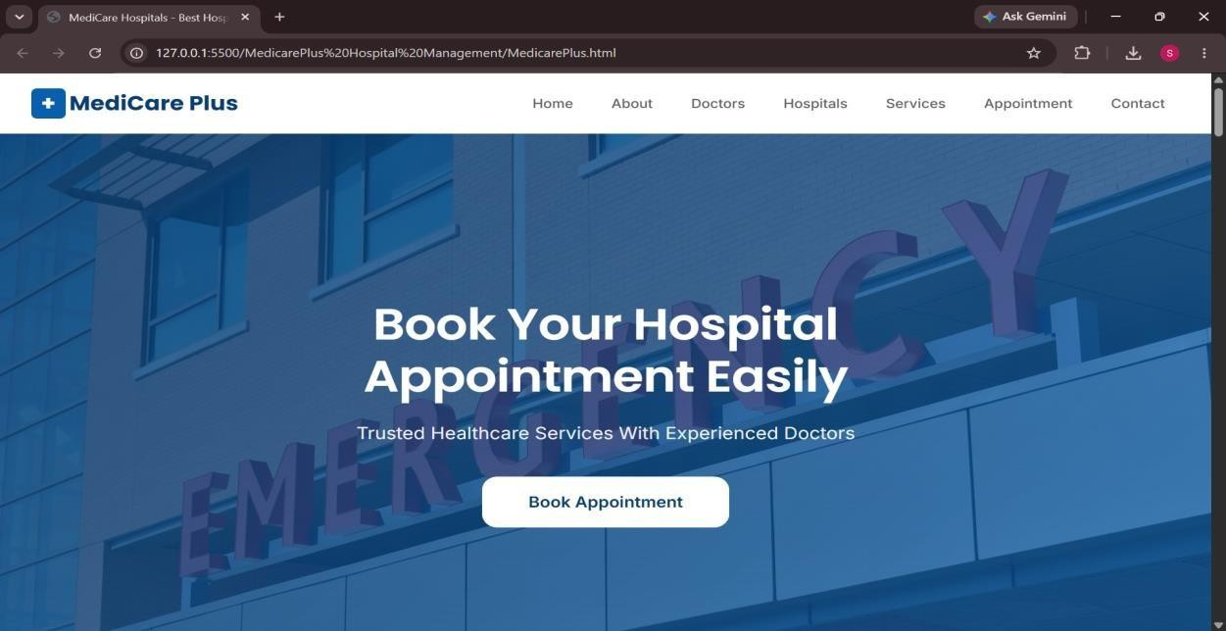

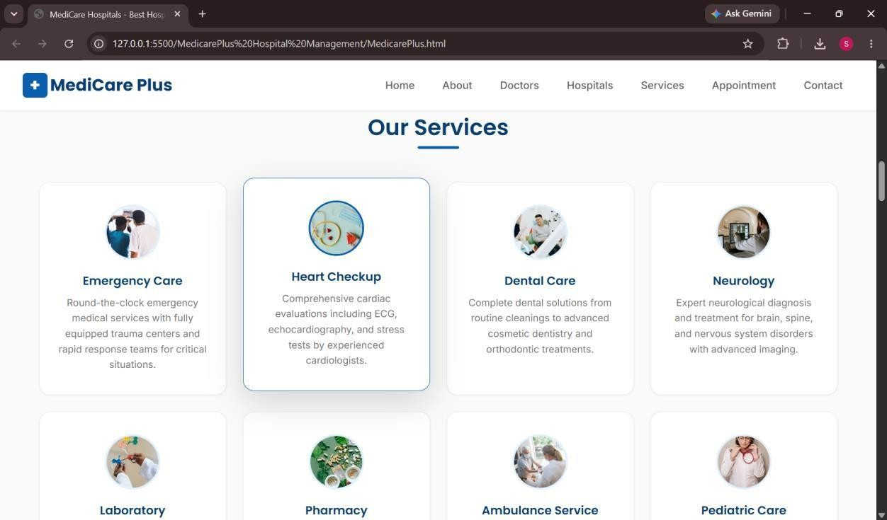

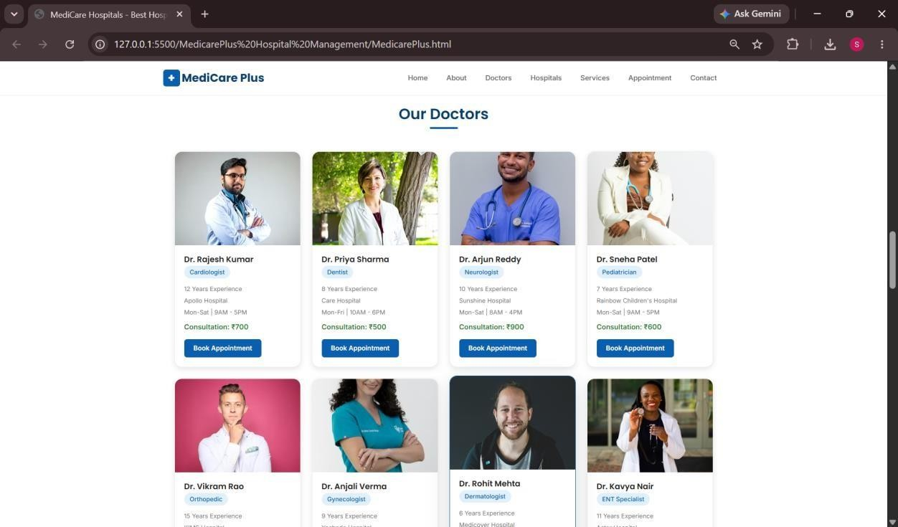

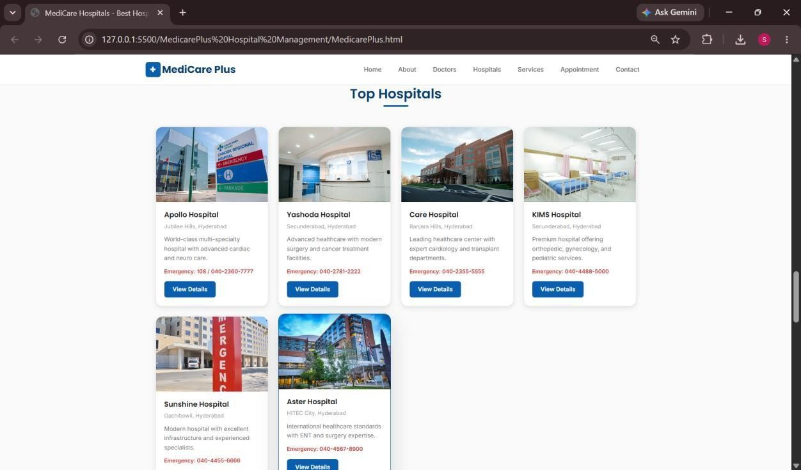

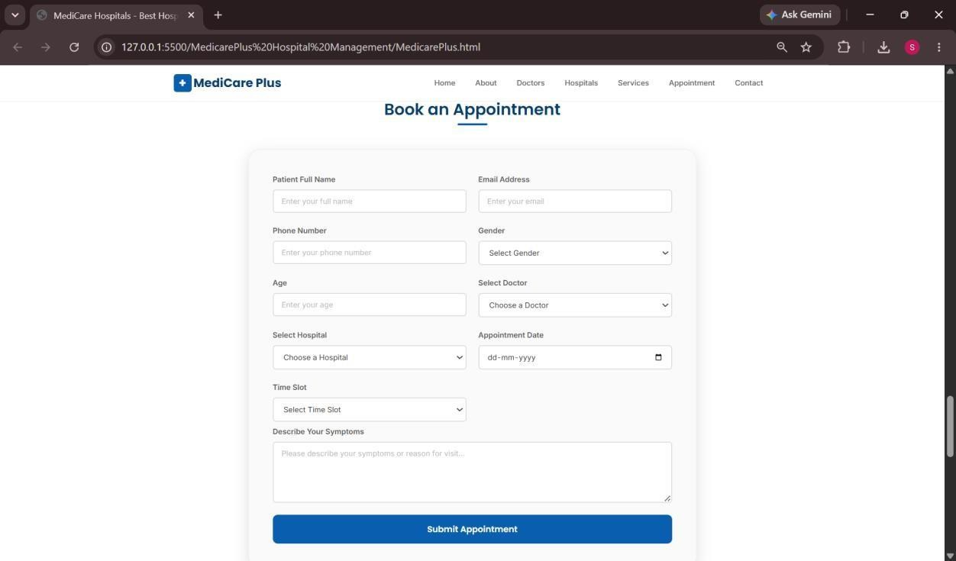

EXPLANATION OF TAGS :
- <!DOCTYPE html> tells browser this is an HTML5 page.
- <html> starts the webpage.
- <head> contains title, CSS, and page settings.
- <meta charset="UTF-8"> supports symbols and text.
- <meta name="viewport"> makes page mobile responsive.
- <title> shows page name in browser tab.
- <style> contains CSS design code.
- <script> contains JavaScript working code.
- <body> contains all visible webpage content.
- <div> is used to divide page into sections.
- <span> is used for small inline navbar text.
- <h1>, <h2>, <h3> are heading tags.
- <p> is used for paragraph text.
- <input> creates pickup, drop, date, and time boxes.
- <button> creates clickable buttons.
- <img> displays the ride image.
- .navbar designs the top black menu bar.
- .container arranges left text and right image.

